

**THE NATIONAL REGIONAL GOVERNMENT OF OROMIYA**

**OROMIYA PLANNING AND DEVELOPMENT COMMISSION**

**PHYSICAL AND SOCIO-ECONOMIC PROFILE OF HORO GUDURU WELEGA ZONE**

**April, 2022**

**Finfinne**

**THE NATIONAL REGIONAL GOVERNMENT OF OROMIYA**

**OROMIYA PLANNING AND DEVELOPMENT COMMISSION**

**PHYSICAL AND SOCIO-ECONOMIC PROFILE OF HORO GUDURU WELEGA ZONE**

**Introduction**

Ethiopia is Located in tropical hot zone around the equator. At the Beginning of the fall down of the darge Regime, the country followed decentralization police which is good system to address the questions of the populations. Oromia region is one of the widest regions that it has different kinds of peoples who come from the other regions, country and who born in the region make their livelihood engaged on different types of occupations. The region also rich in natural resources such as minerals, endemic wild animals and water fall that attract tourists& investors from the foreign countries. From these resources the region gets restrain be attractive income, so that it increases its growth domestic product (GDP) of the region from time to time.

Now a day, Oromyia region has twenty One (21) Administrations Zone. From these Zones Horro Guduru Wellega Zone is one of the popular Zones, which has attractive cultural religions and natural resources.

Up to the end of 2012E.C Horro Guduru Wellega has 11districts with one urban administration (Shambu towns) and classified in to **176 rural peasant associations** and **27 urban kebeles** including Shambu town the zonal capital city. Shambu is the capital town of the Zone, located about 315 away from the capital City of Oromia called Finfinne.

Availability of reliable and up to date information of an area, regarding natural resource band existing socio economic situations, is curtail for preparing proper development plans, under taking research activities and making decisions as well as taking proper measures regarding the area. The profile covers wide range of data and information on geography, population, socio-economic parameters, social service, infrastructures and productive sectors. This compiled profile is so expected to provide a vital source of information about Horo Guduru Wellega Zone physical setting and its socio economic conditions to many policy makers, planners, researchers, donors,

Horro Guduru Wellega holds considerable potential for economic development. The zone’s agro-ecological condition gives an opportunity for the cultivation of an equally varied range of crops. Agricultural products such as cereals, oilseeds, pulses, hides and skins are major products of the zone which provides food for the expanding population. However, agricultural productivity are constrained by several factors including traditional farming methods, limited use of modern technologies, fragmentation and reduction of farm size due to rapid population growth that negatively affect the output of food crops.

Agriculture also provides employment for large number of the population and similarly accounts larger share of the gross domestic product (GDP). The objective being increasing both output and productivity as the foundation of economic growth, the attainment of food security and the creation of employment opportunities in harmony with sound management of natural resources.

Basic facilities such as education, health institutions, water, road net works, electricity and communications are also the most important infrastructure which should be rendered priority for the development of the zone.

**Map 1**; Map of Horo Guduru Wellega Administrative

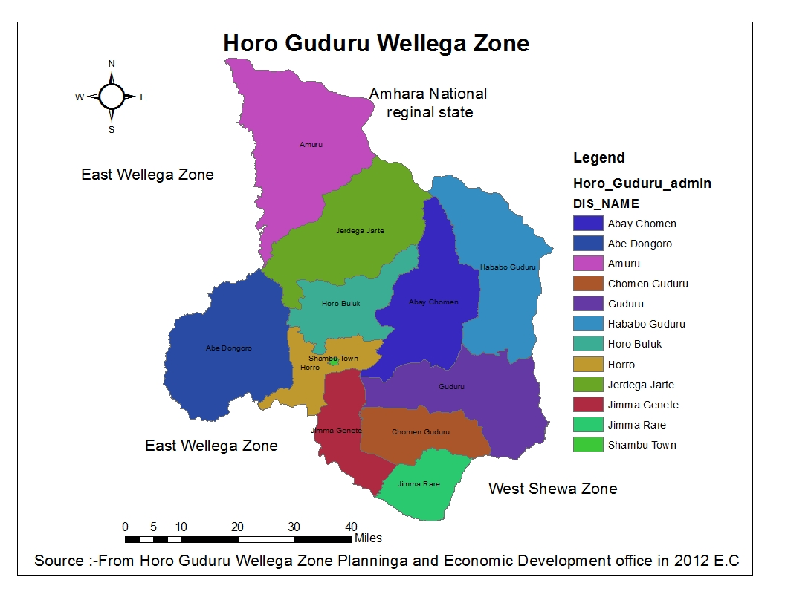

**Physical Setting of the Zone**

**Location**

Horro Guduru Wellega Zone is astronomically located 10017’00”N – 9010’50”N latitude and 37040’00”E – 36039’45”E longitude. The Zone is contiguous with Amhara National Regional state in the North, west Shewa zone in the East, in the West, East Wellega zone, in the South West Shewa and East Wellega zone. Administratively it is divided into 11 districts and 1 city administration (Shambu city Administration).

**Total Area of the Zone**

According to Regional Statistics and information from Department Agricultural office, the total area of the zone is **8244.41 km2 (7868km2_)**the areas of the districts vary from district to district. However, the following table and chart shows us the areas of each district.

**Table 1:** Capital city, Area and PA’s of the districts of the zone

|  |  |  |  |  |  |
| --- | --- | --- | --- | --- | --- |
| No. | Name of districts | Capital town | Area (2) | Number of peasant associations (Rural kebeles) | Urban Administrative kebele name |
| 1 | Hababo Guduru | Dedu | 979.65 | 12 | 2 |
| 2 | Abayi Chomen | Fincha | 863.98 | 17 | 4 |
| 3 | Abe Dongoro | Tulu Wayu | 1096.3 | 21 | 2 |
| 4 | Amuru | Obora | 1295.29 | 21 | 3 |
| 5 | Comen Guduru | Aga | 455.15 | 11 | 2 |
| 6 | Guduru | Kombolcha | 888.4 | 20 | 5 |
| 7 | Horro | Shambu | 355.81 | 11 | 0 |
| 8 | Horro Buluq | Sekela | 510.17 | 11 | 1 |
| 9 | Jima Genet | Harato | 411.5 | 13 | 1 |
| 10 | Jima Rare | Wayu | 344.14 | 18 | 2 |
| 11 | Jardaga Jarte | Alibo | 1038.89 | 21 | 3 |
| 12 | Shambu town | Shambu | 5.13 | - | 2 |
|  | Total |  | 8244.41 | 176 | 27 |

Source: -Oromia Regional BOFED, 2008E.C

The parsantage coverage Area of Horo Guduru Wellega Zone Districts According to the below pie chart Amuru district is Occupied the highest parsantage covered from the other districts in the zone which is 16%.but shambu town is occupied the list parsantage.

**Relief and Drainage**

**Relief**

Horro Guduru Wellega is mainly of low plateau with some isolated ranges of 2000-2500m such as Jimma Rare and Jimma Genet. However, there are high peaks of over 3000m (Gudane in Jimma Genet Mountain 3230m).

**Drainage**

The drainage pattern of the zone is the result of various structural events that took place in the past geological areas. Drainage pattern refers to the fabrics or arrangements of the main rivers and their tributaries shaped by the nature of the undulating rock and slope of the surrounding.

Many rivers and streams drain in Horo Guduru Wellega Zone. Some of the major rivers found in the zone are Abay, Anger, Dimtu, Asati, Chago, Fincha, Erer, Dangago, Qarsar, Dora, Dobi, Dildila Aba Gada, Jaben, Wangela, Dar’o, walage, Qacalu, Hangar, Qarsa, and Gurat Galanan. On other hand, there are two manmade lakes in the zone. Those are Fincha Amarte and Nashe lakes which are used for hydro-energy and irrigation, such as Fincha Sugar Cane Plantation.

**Climate**

The temperature of Horo Guduru Wellega zone is a moderate climatic condition despite its altitude location in tropical climate modified by its latitudinal location. It implies temperature determined by latitudinal location, altitude, prevailing winds …etc. These create seasonal and temporal variation in temperature that is an important factor in vegetation adoption, agriculture production, and settlement pattern in the zone.

The Average temperature of Horro Guduru Wellega is 7.86% is dega which annual temperature of 10co – 15co and 2300m-2300m, 54.75% is woyne dega which is annual temperature of 15co – 20co and 1500m-2300m an d 37.89 % is kola which is annual temperature above 20c 0 and1000m-1500mbelow and above sea level . The annual rain fall of this zone is minimum 1200mm, median 1500 and maximum 2700 mm. The total temperature of this zone is 12c0 – 32c0 and the attitude is 1100mm above sea level.

**Soils**

There are different types of soil types found in Buno Bedele zone including much of the soil available in the Oromia region.

There are different types of soils found in the zone. Namely: Loam Soil, Koticha, SandSoil, Red soil, Black Soil, and Aerosols. Cambic Arenosols occurs in Abay Chomen, Guduru, Amuru and Jardega Jarte districts. Haplic Phaeozems occur in Amuru, Jarte Jardega, Abay Chomen, Jima Genet, Horro and Guduru districts.

The fertile soil of the zone has a huge amount of production potential. This huge potential has lost its capacity to give the expected value because of different factors like the present-day growing population pressure in an area resulted in the degradation of the soil in different ways like; an expansion of settlement, land fragmentation, deforestation… etc which exposed for erosion and degradation.

**Vegetation and Wildlife**

Managing forest resources has become one of the most important agendas in climate negotiations, which has resulted in the proliferation of financial mechanisms such as; clean development mechanisms and reducing emissions from deforestation and forest degradation.

According to Horo Guduru Wellega Zone has medium vegetation endowment in the region and stated places in the national level.

Horo Guduru Wellega Zone is the greenest Zone of west Oromia region. The Zone is covered with natural forest which potential for received areas /park/. Those forests of the zone are used as the host of many endemic mammal and birds. Some of the natural forests of the zone are Cato Forest, Gango forest, Joka Forest, Harbu sololo forest, Lome forest, Tulu lafto forest, Bigit forest and others.

The diverse physiographic and climate of provided favorable habitat for quite a wide variety in the Horo Guduru Wellega zone; numerous wildlife resources were believed to exist in Horo Guduru Wellega Zone. Regarding wildlife, the major wild animals found in the zone are Hyena, Monkey, Pig, Ape, Fox, Lion, Tiger, Civet, Baboon, Buffalo, Hippopotamus and different types of birds.

However, these animals and others are changing their residence to other areas where there are more forests and decreasing in their number; merely due to a serious deforestation rate in the zone. As stated above lack of protected areas by government and non-government bodies, illegal hunting and firebreaks are the other reasons for the migration of these wild lives.

**Socio-economic Condition of the Zone**

**Population**

Demographic data is so important in indicating the development levels of size and trends of population variables. It also shows the implementation of population policies and programs in quantitative terms. It is through demographic data that compliance and various with the goals, objective and target of population policy and programmers are evaluated. On top of this when development ventures are anticipated, its focal point is the people. The realization of population policy, objectives require that program planner experts and staff in the population sector have deep knowledge, understanding, and appreciation of the interrelationship between population variables and development where ever the case may be:

The size and rate of growth of the population determine the rate at which production and investment grow if the prefacing level of per-capital income and consumption are to be maintained. Population size and growth directly influence economic activity by determining the potential number of producers and consumers in an economy. Thus, the present trends of population growth, distribution, and structure keep with the level of socio-economic development in the Horo Guduru Wellega zone. In general, rapid population growth has cause population pressure over the available resources and service facilities as well.

The 1999 population and housing census result is the base of population projection all over the country. Based on population and housing census conducted in 2011 E.C, the projected population size of zone is about **799,801** and **822,516** in 2011 and 2012E.C respectively. According to the 2011 E.C population projection, from the total population of the Zone **400, 577 (50.1%)** were male, where as about **399,064** (49.9%) were female; this indicates that the sex ratio was one to one. During this year about **86.71%** of the total populations were rural dwellers, who are total engaged in agriculture and about **13.29%** of urban population.

**Crude Population Density**

Population density tells us how crowded area is, an average. It can help us figure out the resources that a certain area requires, and it can help to compare areas, need to gather data about the area and population size, the unit of population density is people per unit of area. There for in 2011 and 2012E.C crude Population **Density** is 97and 100 persons per square kilometer respectively.

**Table 2;** The total number of Population Projection of in the year 2011E.C

|  |  |  |  |  |  |  |  |  |  |  |
| --- | --- | --- | --- | --- | --- | --- | --- | --- | --- | --- |
| No. | Name of Wereda | Total Number of Population Projection by Sex | | | | | | | | |
| Total Population of Urban and Rural | | | Urban Population Projection | | | Rural Population Projection | | |
| Total | M | F | Total | M | F | Total | M | F |
| 1 | Horo Wereda | 47505 | 23460 | 24045 | - | - | - | 47505 | 23460 | 24045 |
| 2 | Horo Buluk | 56182 | 28119 | 28063 | 6024 | 3008 | 3016 | 50158 | 25111 | 25047 |
| 3 | Shambu Town | 24617 | 12754 | 11883 | 24617 | 12734 | 11883 | - | - | - |
| 4 | Guduru | 88768 | 44423 | 44345 | 10677 | 5626 | 5051 | 78090 | 38797 | 39293 |
| 5 | Chomen Guduru | 47317 | 23401 | 23916 | - | - | - | 47317 | 23401 | 23916 |
| 6 | Hababo Guduru | 62710 | 31493 | 31217 | 3881 | 2096 | 1785 | 58829 | 29396 | 29433 |
| 7 | Abay Chomen | 68733 | 35320 | 33213 | 15498 | 7982 | 7516 | 53236 | 27538 | 25698 |
| 8 | Jimma Genete | 89753 | 44435 | 45318 | 11436 | 5721 | 5715 | 78317 | 38713 | 39604 |
| 9 | Jimma Rare | 78460 | 38674 | 39786 | 14172 | 7020 | 7152 | 64288 | 31654 | 32633 |
| 10 | Jardaga Jarte | 68316 | 34169 | 34147 | 7809 | 3942 | 3867 | 60507 | 30227 | 30280 |
| 11 | Amuru | 74983 | 37252 | 37751 | 8031 | 4030 | 4001 | 66952 | 33221 | 33731 |
| 12 | Abe Dongoro | 92457 | 47077 | 45380 | 4135 | 2083 | 2052 | 88322 | 44994 | 43328 |
|  | Total | 799301 | 400577 | 399064 | 106280 | 54242 | 52038 | 693521 | 346512 | 347008 |

Source; OPEDC, Stactical Abstract Population Projection year 2011E.C

**Table 3;** The total number of Population Projection of in the year 2012E.C

|  |  |  |  |  |  |  |  |  |  |  |
| --- | --- | --- | --- | --- | --- | --- | --- | --- | --- | --- |
| No. | Name of Wereda | Total Number of Population Projection by Sex | | | | | | | | |
| Total Population of Urban and Rural | | | Urban Population Projection | | | Rural Population Projection | | |
| Total | M | F | Total | M | F | Total | M | F |
| 1 | Horo Wereda | 48756 | 24078 | 24678 | - | - | - | 48756 | 24078 | 24678 |
| 2 | Horo Buluk | 57756 | 28908 | 28849 | 6276 | 3133 | 3142 | 51480 | 25773 | 25707 |
| 3 | Shambu Town | 25647 | 13267 | 12380 | 25647 | 13267 | 12380 | - | - | - |
| 4 | Guduru | 91273 | 45681 | 45581 | 11124 | 5861 | 5263 | 80149 | 39820 | 40329 |
| 5 | Chomen Guduru | 48562 | 24017 | 24545 | - | - | - | 48562 | 24017 | 24545 |
| 6 | Hababo Guduru | 64422 | 32365 | 32068 | 4043 | 2184 | 1859 | 60380 | 30171 | 30209 |
| 7 | Abay Chomen | 70784 | 36579 | 34205 | 16146 | 8316 | 7830 | 54638 | 28263 | 26375 |
| 8 | Jimma Genete | 92294 | 45694 | 46601 | 11914 | 5981 | 5954 | 80380 | 39733 | 40647 |
| 9 | Jimma Rare | 80747 | 39802 | 40945 | 14766 | 7314 | 7452 | 65981 | 32488 | 33493 |
| 10 | Jardaga Jarte | 70237 | 35130 | 35107 | 8137 | 4107 | 4030 | 62100 | 31023 | 31077 |
| 11 | Amuru | 77081 | 38294 | 38787 | 8366 | 4198 | 4168 | 68715 | 34096 | 34619 |
| 12 | Abe Dongoro | 94957 | 48349 | 46608 | 4308 | 2170 | 2138 | 90649 | 46179 | 44470 |
|  | Total | 822516 | 412162 | 410354 | 110727 | 56531 | 54216 | 711790 | 355641 | 356149 |

Source; OPEDC, Stactical Abstract Population Projection year 2012E.C

**Agriculture**

Agriculture is the minster of the zone people and hence it provides almost the largest shared of livelihood of the population. However, agriculture activities in the zone are characterized by a lack of access to modern technology, marketing Facilities low productivities dependence on seasonal rainfall, and lack of irrigation practices at large as a result agricultural economy remains subsistence in its nature. Despite the fact, still, Horo Guduru Wellega zone is potential rich infirming practice. The agro-climatic condition of the zone which is predominantly subtropical is suitable for cereal, pulse, and oilseed production.

Horo Guduru Wellega zone is also ideal for the production of root crops such as, Vegetables, Root crops, and Sugar cane are also cultivated in the zone. In addition, it is relatively free from meager and erratic rainfall distribution, which has a great impact on rainfall for agriculture. Mixed farming is also the common practice prevailing in the zone. As a result, the level hood of the rural people is dependent on both crop cultivation and livestock rearing.

This area received high rainfall and there is no drought-affected area in the past two years. Horo Guduru Wellega zone is one of the agricultural areas of the Oromia region as well as Ethiopia. According to the statistical abstract collected by Woreda Planning and Economic Development office, the major parts of the population are rural dwellers and participated in agricultural practices.

**Peoples affected by Droughts**

Basically, there is no country, region or locality that is self sufficient in food and non food items especially in developing countries like Ethiopia. Regarding the zone in consideration in particular, even though due to traditional farming and rain fed cultivation system, the output of agricultural production is low, food insufficiency is not regular relatively. However, due to the policy of the government to improve food security and poverty dimension of the region, people from food insecure and degraded areas were settled in to the zone in considerable number. This condition, make the zone more susceptible to food insufficiency and expect food aid; although there was no tangible information on the mentioned issues. In the same way, no information available the occasion when drought was so sever in the last five years to the extent that affect the economic base of the zone.

**Cooperative Association service**

There are about 381 cooperative services in the zone. The cooperative service have 140,704 (**117607**males and **23528** females) members in 2012E.C the same year .The total capital of the cooperative service was 219,374,529.The principal task of these co-operative are the supply of agricultural inputs like artificial fertilizers and improved crop varieties to their members and providing different devices for their members.

**Table 4:** Number of Cooperative members and capital of each district in the zone

|  |  |  |  |  |
| --- | --- | --- | --- | --- |
| Year | Members | | | Capital |
| 2012E.C | Male | Female | Total |
| 117,607 | 23,528 | 141,135 | 219,374,520.00 |

Source: Horro Guduru Wellega cooperative and marketing office,

**Land Resources by Use**

Due to scarce resources regarding land use and land cover of the Horo Guduru Wellega Zone the team has enforced to use the data on the physical geography of the zone which is prepared by Horo Guduru Wellega Zone Agricultural Development office in the year 2011 and 2012E.C. The land use pattern of the zone can generally be classified into rural and urban area intensively and moderately cultivated area, forest land, grazing land, bush and shrubs land and for others land use are included.

The term land use refers to the ways that people use land and the natural resources it provides. The total area of Zone is **8,244.41km2,** .Out of the total area, about 27% cultivable land, 31% Grazing land, 24% covered with forest land, 11% cultivated land and 7% suitable for forest Land use/land cove.

The major economic activities of the people, like the economy of the nation, are based on agriculture. The zone is suitable for a variety of crops cultivation. The major crops widely grown in the zone are Teff, wheat, maize, and anther vegetable include Potato, according to the zonal agricultural and rural development office, and the major land use in the zone is occupied categorized into grazing land, Cultivable land, Forest land, Cultivated land, and other.

**Fig 2;** Land Use Land Cover of the Zone

**Crop production and Area of cultivation**

According to data of the rural and Agricultural Development office of Horo Guduru Wellega zone, the total area cultivated by annual crops in the zone in 2011 and 2012E.C; Crop production is basically for subsistence and not based on market demand. Cereals are the most predominant production with very insignificant amount of cash crops such as oilseeds, coffee and chat. Seasonally, most of the production falls in ‘Meher’ season while Belg production is not common and is irregular. Creals such as Teff, Wheat, Barely, Sorghum and Maize are among the dominant cereals produced in the zone. In general from the total cultivated land of **216,187**hektars of land about **6,907,807** quintals of production was obtained in2011 E.C, where as in 2012 cultivated land of **485,258** hectares of land about **6,766,959** quintals of production was obtained normal meher season.

**Table 5;** The total Agricultural Production in the Year 2011 and 2012E.C

|  |  |  |  |  |
| --- | --- | --- | --- | --- |
| Type of Crop | 2011E.C | | 2012E.C | |
| Area | Productions | Area | Production |
| **Cereals (total)** | **216,187** | **6,907,807** | **485,258** | **6,766,959** |
| Teff | 59,411 | 932,451 | 93,611 | 647,776 |
| Barley | 24,695 | 725,297 | 42,619 | 421,632 |
| Wheat | 55,534 | 2,021,587 | 97,428 | 1,594,274 |
| Maize | 55,769 | 2,504,885 | 231,987 | 3,583,972 |
| Sorghum | 20,778 | 723,587 | 19,613 | 519,305 |
| Pulse | 29270 | 297,900.35 | 29,949 | 626,365 |
| Faba beans | 16089 | 168244.5 | 14,736 | 462,025 |
| Field peas | 5376 | 45033 | 6,599 | 59,606 |
| Haricot beans | 3376 | 43749 | 4,216 | 61,111 |
| Chick-peas | 37 | 444 | 84 | 588 |
| peas | 4392 | 40429.85 | 4,314 | 43,035 |
| Oilseeds | 78881 | 1105484.6 | 81,663 | 559,540 |
| Neug | 49841 | 877747 | 55,477 | 389,864 |
| Linseed | 1325 | 8972.6 | 1,059 | 7,757 |
| Groundnuts | 8728 | 77937 | 2,340 | 16,380 |
| Sesame | 18987 | 140828 | 22,787 | 145,539 |
| **Total** | **324,338** | **8,311,192** | **596,996** | **7,952,864** |

Source: Horro Guduru Wellega Zone annual statistical abstract in 2011 and 2012 E.C.

**Agricultural Calendar of the zone**

The Crop Calendar is a tool that provides timely information about seeds to promote local crop production. It contains information on Land preparation, planting (sowing), weeding, flowering, maturing, and harvesting periods of locally adapted crops in specific agro-ecological zones.

Agricultural Calendars of the Zone differ according to the weather condition of the zone. Even if there is no complete boundary of activities in the Zone there are some gaps between activities.

Land clearing was start in the month of March – May which is at the beginning of the rainy season. The rain season starts at the middle of March and it ends at the month of October. The following table indicates agricultural calendar and agricultural activities of the zone.

**Table 6:** Agricultural calendar and agricultural activities

|  |  |  |
| --- | --- | --- |
| N o | Activities | Month(operational months) |
| 1 | Land clearing | March-May |
| 2 | Sowing (planting) | April-July |
| 3 | Weeding | June-October |
| 4 | Harvesting | November-March |
| 5 | Storing | January-October |

Source: Horro Guduru Wellega zone Agriculture development office, 2012E.C

**Number of Development Agent (Extension Service)**

The total numbers of development centers in the Zone in year 2011 and 2012E.C were 527 and 589 development agents respectively. In 2012.C From 99908 households about 80303 households were benefited from 176 kebeles.

**Livestock, Poultry and Beekeeping**

This sub-sector plays a significant role in the economy of the zone directly and indirectly. Livestock is generally the source of food (milk, meat, egg, etc) means of income-generating, (for cultivation transportation, etc), means of foreign currency earning for a country by exporting skin, hide, meat, and serves as saving. They also kept as wealth and indication of status.

The livestock component of the zone comprises Cattle, Ship, Goat’s, Horses, Mule’s, donkeys, and Poultry. It also contributes to the farmers in two ways. One is the input function, which includes traction power transportation and manure, while the other is the output function, which refers to nutrition (milk, meat, egg, etc) and cash.

Livestock play a great role in day-to-day life of society, especially in peasant life. They provide meat and milk, transport, manure, skin and hide & furnish regular & easily realizable cash income. But, in contrast to the size of the live stock population, physically and value productivity are low. According to Zone Livestock Development, Health and Marketing Office data of 2012E.C there were about **1,596,743**cattle, **265,480** goats, **305,091** sheep, **14,540** mules, 1**141,925** donkeys, **85,688** horses. For detail, see the table below.

**Table 7:** Livestock and poultry population of the Zone during 2011 and 2012E.C

|  |  |  |  |  |  |  |
| --- | --- | --- | --- | --- | --- | --- |
| Year | Cattle | Goats | Sheep | Donkeys | Horses | Mules |
| 2011E.C | 1,530,015 | 259,490 | 317,810 | 123,284 | 89,546 | 10,431 |
| 2012E.C | 1,596,743 | 265,480 | 305,091 | 141,925 | 85,688 | 14,540 |

Source: Zonal annual statistical abstract, 2011&2012EC

Regarding Animal disease in the zone, the main diseases affecting the livestock resources are Trypanosomiasis, Internal parasites and external parasites, Infectious diseases and blood urine that entire attack domestic animals especially ruminant animal. Traditionally, farmers perform honey production not as a major duty but in their spare time. They use a local beehive from the available local materials and the amount of honey they obtain from this beehive is relatively lower than the honey that can be obtained from the modern beehive.

The major problems hindering agricultural productivities in the zone are land degradation, erosion, variable rainfall, unimproved agricultural technology, small sizes of land holding and fragmentation, insufficient supply of agricultural inputs (fertilizers, improved seeds, pesticides) and inconveniency of rural feeder roads to supply agricultural inputs to peasant holdings and to access agricultural products to market. Furthermore, poor and insufficient irrigation schemes, low emphasis to market system and poor infrastructure and lacks of credit facilities as well as lack of technical support are some of constraining factors that adversely affect agricultural productivity.

**Minerals and Industry**

**Minerals (Mining)**

Minerals are all-natural materials made up of rocks and soils, whether they are economically valuably or not.

**Industry**

Investment of industry is plays a pivotal role to accelerate the rate of economic growth, create employment opportunities and eradicate poverty as well as improving the living conditions of the people.

Industry is one of the important productive sectors to bring about sustainable economic development. It consists of manufacturing, mining and construction. Despite its paramount importance in economic development at large; The contribution of industry in the zone is very insignificant due to shortage of capital, technology, market, skilled man power and infrastructural facilities. Although, there is no available and tangible data on small scale industries in the zone; there are considerable number of flour mills, saw mills, meat processing industries and brick and Blocket manufacturing industries available in the zone in the mentioned year under non-government ownership. Among medium and large industries Fincha Sugar Factory is the most dominant manufacturing industry owned by government in the zone.

**Minerals**

There is no sufficient information on the availability and deposit of mineral resources in the zone. However; the current data obtained from Horo Guduru Wellega Zone concerned body; there are many mineral resources in our zone. The Major mineral resources known in the zone are; Metallic (Iron), Construction mineral (Stone, Sand and other)… etc, found in different districts of our zone.

Horo Guduru Wellega has plenty of mineral potential like metallic iron, non- metallic (Mineral water and hot spring) and Construction minerals (sand stone, clay soil, marble and Coble Stone). They have specified area in different districts of the zone, but the potentially available reserve in ton and their commercial use is such as for Constructions, Building and some of them not clearly known due to absence of detail study.

**Table 8**: Area of Minerals found in the zone

|  |  |  |  |
| --- | --- | --- | --- |
| Name of the minerals | Specific area | Actual production  ( in ton) | Commercial use of minerals |
| Metallic (Iron) | Amuru, Horo, Abe Dongoro | * | For construction |
| Construction mineral  (Stone, Sand and other) | Amuru, Horo, Jardaga Jarte, Abay Comen | * | For construction |

**Infrastructure and Social Facilities**

**Transport and communication**

Transport and Communications play a very important role in any development endeavor. It would be impossible to conceive of social and economic development in the absence of adequate transport, communication infrastructure, and services.

**Road and Transportation Facilities**

Road is one of the major components of infrastructural facilities which allows the movement of goods and services to markets. Without an efficient and effective road network, economic and social developments have a positive impact on socio-economic development and multiplier effect on rural development and strengthen urban economic productivity. Without the road, service delivery growth is unthinkable.

Horo Gudu Wellega zone is one of the zones that have a well all weather road from zonal administrative center. Abay Chomen, Guduru, Hababo Guduru district, Comen Guduru Jima Rare, jardaga jarte District and shambu admistrative town have an Asphalt road, but others districts have no asphalt road.

The relation between rural development and Urbanization and economic growth relies on adequate road coverage and development that support social and economic development. An efficient road network has a greater impact on the livelihood and benefits of the people living in the locality and overall economic development by connecting them and facilitating the movement of goods and services.

There was a road constructed previously by the rural road and urban road construction without plan. In some district the road constructed cannot be passed in some direction as example Abe Dongoro and Amuru great problem that serve the people for transport still today.

Generally, the Zone has a great problem of transport. Hence, it can be concluded that any concerned body should give attention to solve this serious problem related to the transport services. Regarding communication, the telephone service in the zone starts from the recent time. Telephone services like Digital telephone and Mobile telephone are used by the users in the Zones. Most of districts in the zone does not have postal service, there is as service at agent level.

**Map 2**; Type of Road Distribution in the Zone

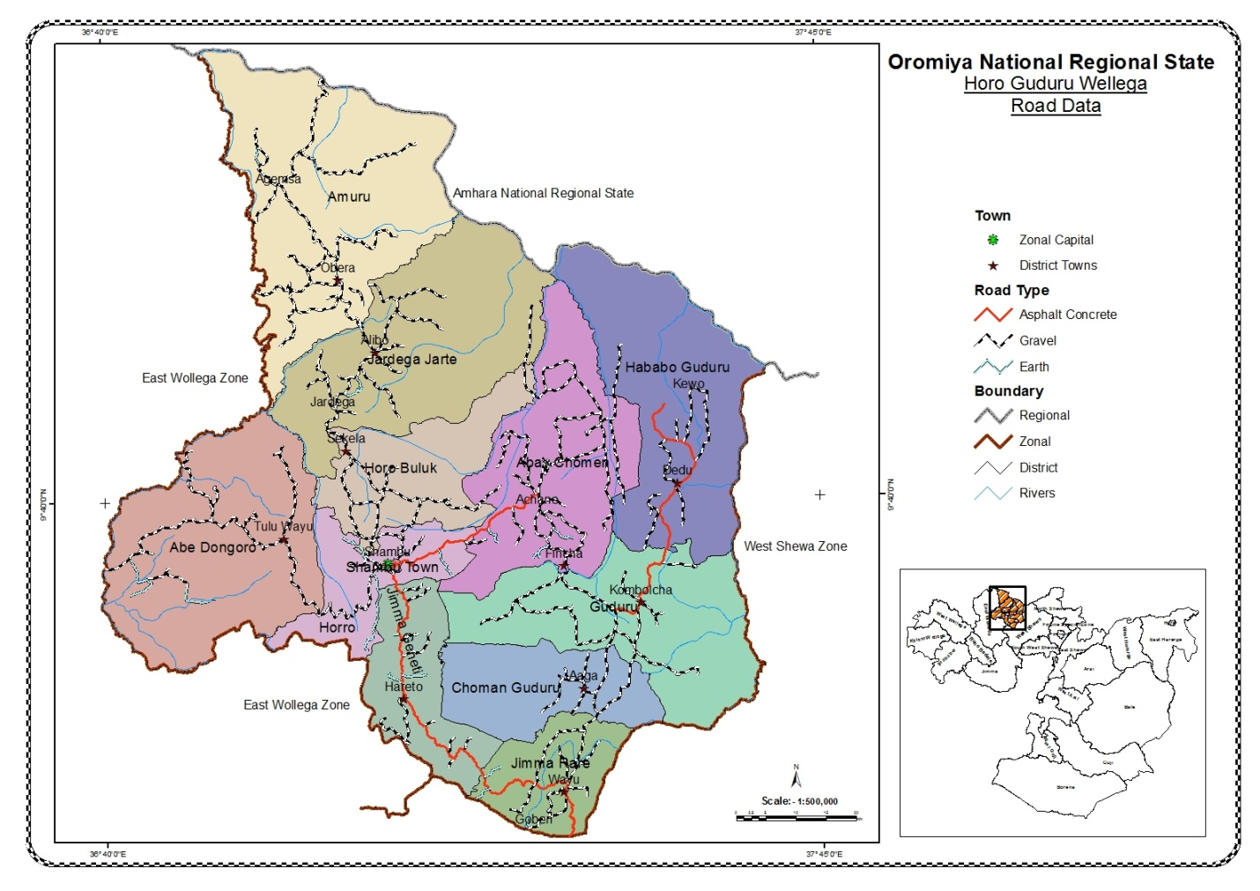

**Source;** OPDC; Directories of Socio-economic Profile and GIS; team of GIS 2013

**Communication:**

Information technology has made life easy and simple in many developed countries by modernizing and easing the collection and dissemination process of information due to their successful ICT development. Information technology gives current information from the latest information technologies for producers and consumers likely, connect product suppliers and transport services, increase social tie-ups and save time and energy of the community who used to travel long distances to get various public services. Many people are coming more eager to be equipped with information and updated with fresh news about the zonal, region, country, and the globe at large. The role of media, information technologies, communication services, and networks like telephone, internet, fax, and postal services are very important to speed up all-rounded development.

Information technology has been the chief device in the structural transformation of the Horo Guduru Wellega Zone. However; this does not mean that it is being at used fully extent that by the local community needs at the Zonal level and the Wereda level.

**Water and energy supply**

Water is indispensable resource for the survival of life on the earth. Every movement of living things, either from one place to another or growth in specific area it is attached to the availability of water. The value (price) given for water is not according to its usefulness for its presence everywhere & full year drain. The available under ground water is the great future potential of development. Though there is hardly available studies data in hand at a moment, there could be great potential underground water in the Zone.

The sources of water for home utilization are mainly from wells and springs for urban & rural dwellers. According to available information from the zone water, minerals and energy office indicates that, out of the total population in the Zone, about 64.75% in 2011 and about 76.27% in 2012E.C supplied with potable water. For detail, see the table and on the pie chart below.

**Table 9:** Total population supplied with portable water supply in the zone

|  |  |  |  |
| --- | --- | --- | --- |
| Year | The total population of the district  (Urban &Rural) | Population supplied with portable water | % age of pop. supplied with portable water |
| 2011.E.C | 799,801 | 517,898 | **64.75** |
| 2012E.C | 822,516 | 627,369 | **76.27** |

Source: Districts Water, Mineral and Energy Office, 2011 and 2012E.C

The sources of drinking water according to their importance in the zone for urban areas are well, river and tap water, where as the rank according to the importance of sources of drinking water for rural areas in the zone are river, well and tap water during indicated years.

Regarding source of domestic energy supply, the sources of domestic energy supply according to their importance in the zone for urban areas are fire wood, charcoal, Electricity, kerosene, crop residue and animal dung, whereas the rank according to the importance of sources of domestic energy supply for rural areas are firewood, crop residue, animal dung, charcoal, kerosene and

The sources of drinking water according to their importance in the zone for urban areas are well, river and tap water, where as the rank according to the importance of sources of drinking water for rural areas in the zone are river, well and tap water during indicated years.

**Map 3;** Source of Potable Water Distribution in the Zone

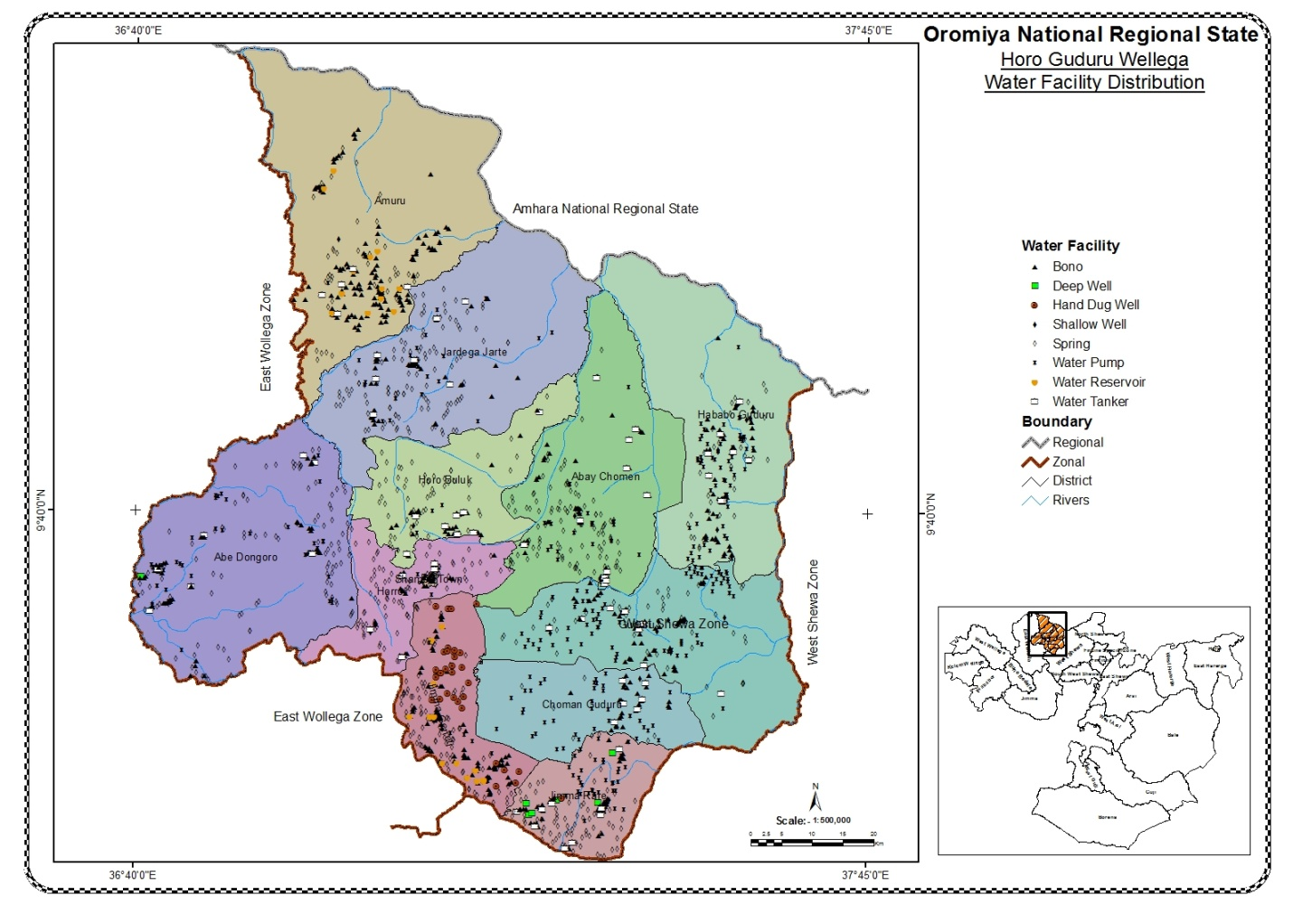

**Source;** OPDC; Directories of Socio-economic Profile and GIS; team of GIS 2013

**Energy Supply**

Energy is the lifeblood of an economy and the backbone of sustainable developments which is required in all sectors of development. It is an engine for any socio-economic development, a basic ingredient in national economic development to generate employment and improve the living standard of the urban population. It is undeniable fact that power is the spinal cord of any economy that plays important role in changing the livelihood of the people and economic and social developments like industry, trade, communication and so on.

There is no detail information on domestic energy supply data. However, it is clear that the main domestic energy supply in the zone is firewood that is collected from the forest; Eucalyptus provides supplementary source energy for those who have the eucalyptus trees; some households use dug, crop residue, and kerosene too. Urban residents use firewood and charcoal and kerosene. Almost all towns and some rural villages in the zone have electrical power.Regarding source of domestic energy supply, the sources of domestic energy supply according to their importance in the zone for urban areas are fire wood, charcoal, electric power, kerosene, crop residue and animal dung, whereas the rank according to the importance of sources of domestic energy supply for rural areas are firewood, crop residue, animal dung, charcoal, kerosene and electric power**.**

When we see the uses of energy in the zone we have to categorize them in rural and urban populations. According to the data we have at hand in rural areas of our zone firewood, charcoal, crop residue, kerosene, dung, and electricity ranked from first to sixth respectively. In urban areas of the zone, it is reverse to that the rural districts, which means electricity, kerosene, charcoal are the most used sources of energy. Power is one of the necessities for development. It is also essential for the usual day-to-day life of the people. When we plan for development the occurrence of power as a source of energy plays a significant role.

**Social Service Aspects**

The provision of social services is crucial to improve the well-being of citizens and lift the country from socio-economic backwardness and underdevelopment. Education and health are the basis for any activities taking place in our livelihood improvements. As a result of this, the government bodies at different levels have given due emphasis to the extension of education and health. The achievements in education and health in Horo Guduru Wellega Zone during preceding years are presented as follows;

**Education**

Education plays a vital role in achieving economic development and real social improvement and enhancing the capacity to overtake responsibility and participate intelligently in public life. Also; education is the base for the development of human development society. It provides strength and resilience to people to respond to changing situations and enables them to case and contribute to societal development through development of their attitudes, values, capabilities, both of knowledge and skills. Educated population is crucial for economic and social advancement. Therefore, education is an essential investment in people and as such a pre-requisite for equitable and sustainable economic development.

It is obvious that literate people are more productive than illiterate ones. An educated family has access to broad range of opportunities. For instance, educated farmers are more capable of increasing their productivities and are more receptive to new ideas and technology than uneducated farmer and also educated women tends to have fewer and better educated children and they are also open to the general trends in education.

**Table 10;** The total number of Student enrollment by School

|  |  |  |  |
| --- | --- | --- | --- |
| Situations in school | Level of schools | 2011E.C | 2012E.C |
| Total Enrolment of student | Grade 1-8 |  |  |
| Male | 86,401 | 91,025 |
| Female | 78,556 | 85,965 |
| **Total** | **164,957** | **176,990** |
| Grade 9-10 |  |  |
| Male | 14,851 | 16,685 |
| Female | 11,842 | 14,635 |
| **Total** | **26,693** | **31,320** |
| Total number of teacher | Grade 1-8 | 4,704 | 5,183 |
| Grade 9-10 | 749 | 1,219 |
| Number of school | Grade 1-8 | 320 | 321 |
| Grade 9-10 | 45 | 48 |

Source: -Horro Guduru Wollegaa Zone educational office, 2011 and 2012E.C

The enrollment rate of students in primary school for female students is high and low in secondary school and for male students it was high in secondary school and low in primary school and this creates wider gender gap in secondary school than that of primary school. Net enrollments of male and female students were almost the same in preparatory school depending on the table above.

**School Age population:-**

The school-age population is one of the best indicators for planning and budget preparation of education facilities and expansion of schools to satisfy the social need of education for all policies. In addition to these to keep the education quality with different indicators like student classroom ratio, student textbook ratio, student teachers ratio, and others school-age population is too essential.

According to the available data of Horo Guduru Wellega Zone, many children are attending school now a day. Provision of primary education and improving the quality of education is the focal area of the educational strategy of the government.

For the last two years, many school facilities were started rendering services. Trends’ also indicating that encouraging progress has been made in Horo Guduru Wellega zone for the last two years.The education policy mainly emphasizes the provision of basic primary education to all citizens freely and equitably. All efforts are geared to ensure that education at all levels is relevant and responsible to the socio-economic and cultural development needs of the people.

**Number of students enrolled by levels of schools;**

The total number of students attending **(enrolled)** their regular learning activity in the zonal primary school in the years 2011 and 2012E.C is; 164,957 and 176,990 Primary school also 26,693 and 31,320 Secondary school respectively.

**Number of students detained by levels of schools;**

The total number of students **detained** their regular learning activity in the zonal primary school in the years 2011 and 2012E.C is -------- and ------- Primaries school also ------ and ------ Secondary respectively.

**Number of students drops out by levels of schools;**

The total number of students **drops out** their regular learning activity in the zonal primary school in the years 2011 and 2012E.C is -------- and -------- Primaries school also ------- and ------ Secondary respectively.

**Map 4;** Distribution of Education type in the Zone

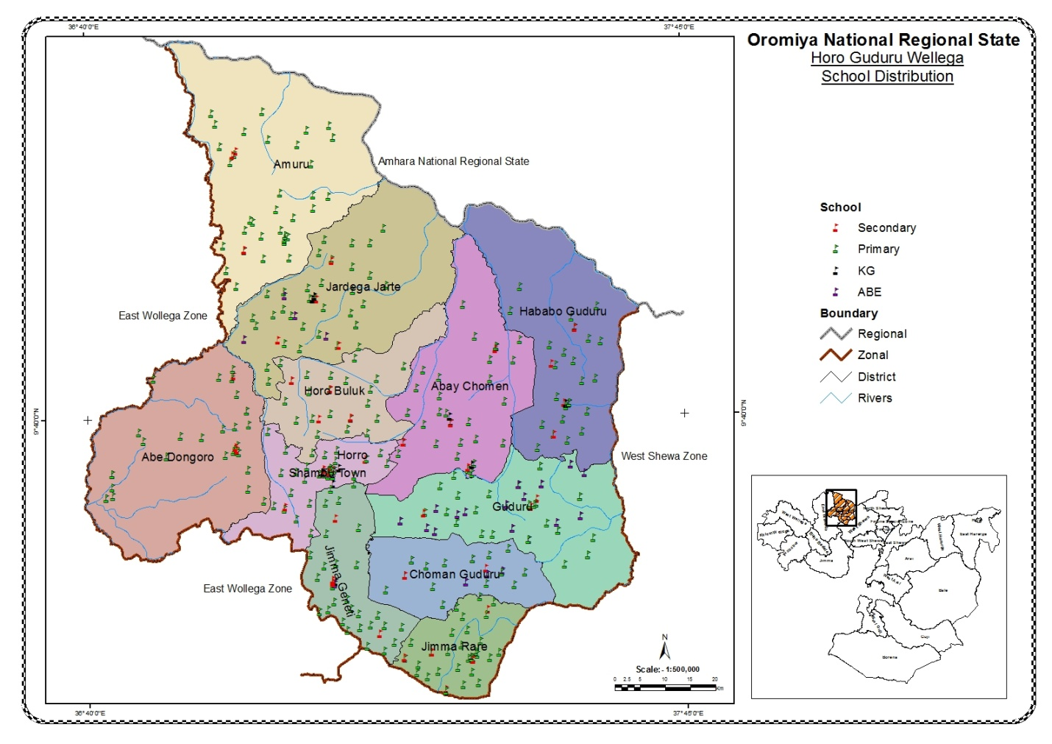

Source; OPDC; Directories of Socio-economic Profile and GIS; team of GIS 2013

**Health**

Health care is one of the fundamental social development indicators of a country and basic demand of the people and number one concerns of every individual that play a significant role to the life enjoyment and efficiency in work. Every individual life is the greatest asset, a precious resource, and security of any nation. He needs to be given adequate protection and care to promote holistic healths and overall wellness.

**Health** **Institution**

Among all needs to be available, a health society, being well and free from any illness, of great important for development. All activities whether economic or social, depend on the physical condition (mental, behavioral, internal body, external body) of human being. Farmers perform farming activities if they have good health in farming season, trade, teaching, learning & all other similar activities can be under taken if health care is properly kept. Health access shows dramatic improvements in the zone. The government has made a strong effort to expand and provide health services at all levels.

However; according to Horo Guduru Wellega Zone, that gets access to health service is below the standard, but the situation is better compared to the near past period. Types of diseases attacking population in this Zone are mostly by Internal parasites, URTI, Diarrhea, Rheumatic, FUO, Gastritis, Eye diseases, Malaria, Skin diseases ,FUO, Teeth Gum diseases and other diseases frequently attack the community both in rural and urban but the degree of attacking is different from urban to rural & within the rural and urban dwellers. According to available data from zonal health office, there were3 hospital, 50 health centers, 0 clinics, 202 health posts, giving services in 2012E.C.

**Health Professional:**

Now a day the number of health professionals working in the zone shows an increasing trend in governmental health institutions. There is also an increase in different health professionals like; Pharmacists, Health officers, Health assistants, and community health workers except for some decreases in those professionals like Doctors, Nurses, laboratory technicians, and X-ray technicians. The table below also gives a brief indication of health professionals in the zone.

**Table 11;** Number of Health professionals working in different Health institution

|  |  |  |  |  |  |  |  |
| --- | --- | --- | --- | --- | --- | --- | --- |
| **No.** | **Health Profession** | **Year** | | | | | |
| **2011E.C** | | | **2012E.C** | | |
| **Total** | **Gov’tal** | **Non-Gov’tal** | **Total** | **Gov’tal** | **Non-Gov’tal** |
| **1** | Doctors | * | * | * | 18 | * | * |
| **2** | Nurses | * | * | * | 481 | * | * |
| **3** | Health assistance | * | * | * | * | * | * |
| **4** | Health officer | * | * | * | 147 | * | * |
| **5** | Laboratory | * | * | * | 85 | * | * |
| **6** | X-ray technicians | * | * | * | * | * | * |
| **7** | Sanitarian | * | * | * | 28 | * | * |
| **8** | Pharmacists | * | * | * | 62 | * | * |
| **9** | Health Extension | * | * | * | 418 | * | * |

**Major health problems:**

According to the zonal health office, the following are the major health problems of the zone are; -----------, ------------, --------------, -------------, and --------------.

**Ten top Diseases in the Zone:**The distribution of major diseases depends on the climatic division of the zone; since our zone is the smallest zone from the Oromia region with diverse climatic conditions, which contributes to the existence of different diseases. When we came to the prevalence of the ten top diseases; among the disease listed on the first rank human disease is any harmful change that interferes with the normal appearance, structure, or function of the body or any of its parts. The most challenging diseases (the ten top diseases) in the Zone in 2012E.C are described in the table below.

**Table 12**: The top ten diseases in the Zone

|  |  |
| --- | --- |
| Top ten diseases | Rank |
| AFI | 1st |
| Pneumonia | 2nd |
| Diarrhea | 3rd |
| URTI | 4th |
| Malaria | 5th |
| Skin Infection | 6th |
| Gastritis/Dyspepsia | 7th |
| Typhoid fever | 8th |
| Injuries | 9th |

Source: Districts health office, 2012E.C

**Map 5; Distribution of Health Institution type in the Zone**

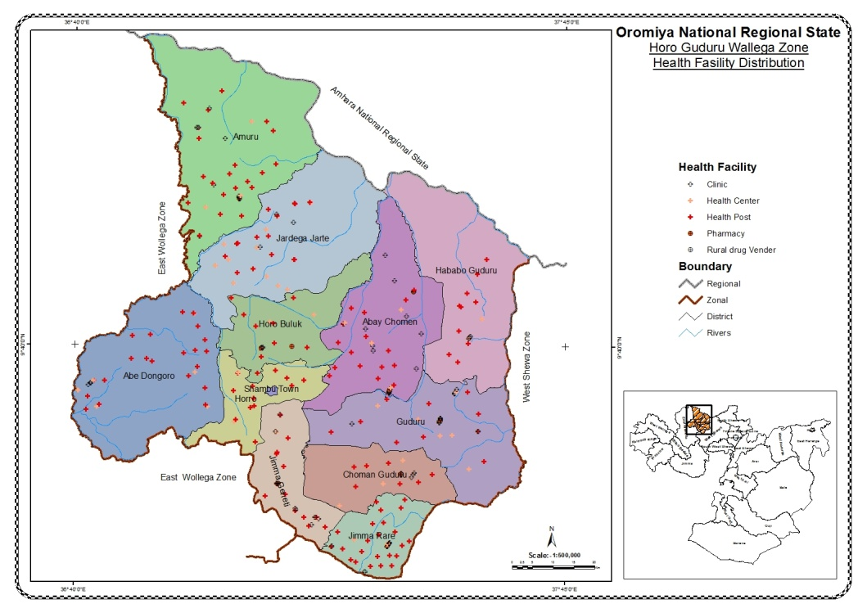

**Source; OPDC; Directories of Socio-economic Profile and GIS; team of GIS 2013**

**Children and Women Socio-Economic Indicators**

The basic point of Ethiopia's constitution pertaining to Women empowerment is equal power and right in social, economic, and political participation. To come up to the backlog as regards gender discrimination some affirmative actions are applied. Women have got ownership title on resources like Land and so on. **At the national level, the women's affairs policy is published in 1992E.C,** and the minister's office and regional level Women Affairs Bureau are set up to make the constitution realistic. The major duty and responsibility of these government institutions are to empower women, awareness creation on gender inequalities, etc.

**Women Issue Indicators**

**Maternal Health:**

The maternal Mortality ratio can only be calculated out of 100,000 live births. But as to our Zone, we don’t have 100,000 live births per year. So we can’t get MMR in just Wereda, Town, and Zonal level, it would be calculated at the regional or national level.

To improve maternal health and to reduce maternal mortality, antenatal care and postnatal care were given by health professionals at different health institutions. To assist safe deliveries and to reduce maternal and neonatal deaths, the number of pregnant women who took checkups was increasing/ decreasing from time to time.

In Horo Guduru Wellega zone in the year 2011and 2012 E.C; -------- and **---------** women were used family planning services respectively. In the same years, -------- and **---------** women have received antenatal health care from health personnel (nurses, mid-wife and health extension workers). Safe birth deliveries and skilled attendance at birth is the most important intervention in reducing maternal mortality. The number of deliveries assisted by skilled health personnel has **increased** from -------- in the year 2011 to -------- in 2012 E.C. The number of women who have received monitoring and health check-ups after deliveries (postnatal care) also increasing/ decreasing;

**Women’s Equal Responsibilities in local and Political:**

To empower women in the zone many attempts have been done and women are taking responsibility in different activities, however, still, the majority of women in the zone were specialized in indoor activities like; cooking, washing, fetching water, collecting firewood, and caring for children. Women’s have equal responsibility with men in political as government give them right, In Horo Guduru Wellega zone there are -------- women’s in the cabinet members in the year 2011E.C and -------- women are selected as cabinet members in the year 2012E.C.

**Table 13;** Women’s participation in socio-political affairs of the zone

|  |  |  |
| --- | --- | --- |
| Women Involvement | Number of women | |
|  | 2011E.C | 2012E.C |
| Number of women elected as cabinet member at (kebele)level | * | * |
| Number of women elected as cabinet member at Woreda(District)level | * | * |
| Number of women elected as cabinet member at zonal level | * | * |

**Children Issue Indicators**

In Horo Guduru Wellega zone, government tries to improve children lives. In the zone, many children go to school now a day. But many children still face many social problems (poverty, health care, education, street children).

**Table 14**; The data of children issue indicators in the zone

|  |  |  |  |
| --- | --- | --- | --- |
|  |  | Year | |
| 2011E.C | 2012E.C |
|  | Coverage of EPI under five(**under one)** | * | * |
|  | Number of Orphan and vulnerable children | * | * |
|  | Number of malnourished children | * | * |
|  | School Accessed to improved water supply | * | * |
|  | Kindergarten | * | * |
|  | Primary School | * | * |
|  | Secondary School | * | * |
|  | School accessed to improved sanitation facilities (toilet etc) | * | * |
|  | Kindergarten | * | * |
|  | Primary School | * | * |
|  | Secondary School | * | * |

**The five top reasons for the increasing infant mortality rate:**

The five top reasons that increase the infant mortality rate in our zone are pneumonia, Aspasia all -----------, -----------, -------------, -----------, and -------------.

**Disabled Children :**

There are different disability cases that occurred in the zone such as deaf, physical problem, mental problem, blindness, etc.  The total number of disabled children in the Zone is; -------- male and -------- female.

**Social Security**

Social Security is public programs designed to provide income and services to individuals in the event of retirement, sickness, disability, death, or unemployment.

Citizens have right to social security, social insurance and right to adequate standard of living including housing among others. Shelter is one of those necessities for the survival of human beings in addition to food and clothing. The history of housing is inseparable from social, economic and political development of human kind and housing habitation is necessary for every person irrespective of his economic and social status. Housing gives basic dignity and every citizen has the right to shelter. There is a trend of more persistent housing construction being there is rapid population growth and high rate of urbanization that leads to a rise in needs for housing and shelter in urban areas.

Most of the houses in the Horo Guduru Wellega Zone were old and constructed from wood and mud also made from local materials known in rural area. However, in the last five years rather than individual hosing constructed modern houses by private and communal houses made of hollow flocks, stone and cement have been constructed. To overcome the housing problem, the Horo Guduru Wellega Zone and the government are begin constructing in the year 2011 and 2012 E.C; the data is not compiled by concerned body.

**Employment and Unemployment Condition**

Unemployment in Horo Guduru Wellega Zone; is a critical problem due to lack of job creation in the formal sector. As with other Zone/Wereda/Town in the zone, it is common to notice streets full of unemployed youths hoping for opportunities. The majority of the population in Horo Guduru Wellega Zone is engaged in informal and small-scale businesses, and the majority of the society life is depends on different private job and also farmers, do not sufficiently benefit from governmental social services. Those engaged in the civil service are few in number; even among these most are paid low salaries.

Number of Unemployed and employed persons registered by sex; there is no efficient and accurate method of learning the degree of unemployment in the Horo Guduru Wellega Zone in particular and in the whole country at large. So far, the only responsible source of information of this nature is the Department of labor and social Affairs. Recently, there is no recorded figurative data of unemployed people in the Horo Guduru Wellega Zone. But in case of employed persons were 14841 (9806 male and 5015female) registered on permanent basis under governmental organizations in the zone in 2012 E.C.

**Table 15;** The number of permanent and temporary Employees Gov. and Non Gov.

|  |  |  |  |  |  |  |  |  |  |  |  |  |
| --- | --- | --- | --- | --- | --- | --- | --- | --- | --- | --- | --- | --- |
| Year | <12 Grades | | Certificate | | Diploma | | Degree | | MA/MSc | | PhD. | |
| M | F | M | F | M | F | M | F | M | F | M | F |
| 2011E.C | * | * | * | * | * | * | * | * | * | * | * | * |
| 2012E.C | * | * | * | * | * | * | * | * | * | * | * | * |

**Number of criminal recorded by types and civil cases:**

The concept of Social security goes much more beyond, in the description below we try to include the number of criminal and civil cases that lodged, decided, and pending cases at the zonal and district courts is deal with social security. However; data by type and number of cases charged and decided is no well organized by concerned body.

**Table16;** The number of criminal recorded by types and civil cases

|  |  |  |  |  |  |  |
| --- | --- | --- | --- | --- | --- | --- |
| Year | Criminal cases | | | Civil cases | | |
| Lodged | Decided | Pending | Lodged | Decided | Pending |
| 2011E.C | * | * | * | * | * | * |
| 2012E.C | * | * | * | * | * | * |

**Finance**

Among duties and responsibilities of finance and economic development office of different levels are collecting revenue and making necessary expenditures. It also pays necessary expenses for different governmental activities being in the area. Accordingly, the finance and economic development office was established at the zonal level to perform similar tasks by integrating different wereda and sectors under the zone. The office like any of the finance offices has its revenues and expenditure.

**Micro-Finance Institutions;**- Many developing economies have developed and providing credit to the poor through microfinance schemes. Horo Guduru Wellega Zone is home to several microfinance institutions (MFIs) that have particularly participated in the petty business. There is small saving and credit institution that supports the community by providing loans and counseling services, which enable the community to engage in the business of their choice and produce according to their ability and skill.

**Revenue and expenditure:** Revenue statistics of Horo Guduru Wellega Zone indicates that in 2011E.C, revenue collected was 143,306,445.47, while in 2012E.C a total of 184,599,386.14 birr was collected. The highest revenue was from direct taxes such as personal income tax, agricultural income tax and land use fee. Regarding expenditure, the total expenditures of the zone were increased to 835,221,690.71 birr in the year 2011 E.C from 1,378,181,375.50, birr in the year 2012 E.C.

**Table 17;** The total amount of Revenue and expenditure

|  |  |  |
| --- | --- | --- |
| Year | Revenue | Expenditure |
| 2011 E.C | 143,306,445.47 | 835,221,690.71 |
| 2012E.C | 184,599,386.14 | 1,378,181,375.50 |

Source: from annual statistical abstract in 2011 and 2012E.C

**Number of banks and Insurance Companies:**

The other very important parameters of financial activity in the zone are the availability of financial institutions which initiate saving and facilitate credit for business activity and economic development. The number of commercial Banks that was ------ in the year 2011E.C, became ------ in the year 2012E.C, The other banking institutions are in the year of 2012E.C, like ---- Oromia cooperative banks, ------ Oromia International banks, ----- Awash Bank, ------ Dashen Bank, ---- Abyssinia bank, ----- Development Bank, and ------ NIB Bank.

**Availability of rural saving and Credit Associations:**

As the data obtained from Horo Guduru Wellega Zone of Finance and Economic Development Offices the total numbers of Government and Non-Government Micro financial institutions were --------. These micro-financial institutions have been provided services for the population living in Horo Guduru Wellega Zone. There are different types of financial institutions in the zone are available which initiate saving and facilitate credit for business activity and economic development.

**Trade, Tourism, and Sports:**

**Trade**

Trade has played a great role in the economic growth of the country since it is strongly linked with the development of transport and other communication technologies. According to the data obtained from Horo Guduru Wellega Zone Trade Agency during in the year 2011 and 2012E.C;

In the Horo Guduru Wellega zone is among the cash crop areas of Oromia National Regional State as well as Our Country. The major cash crops of the zone are oil crop, cereal crop, and so on. There are various types of exportable items from the zone are exported to central market at different time. Among exportable items supplied to the central market, the major ones are hides, sheepskins, goatskins, oilseeds, and cereal crop. The major agricultural products that are abundantly supplied to the local and central markets as different crops like; oil crop, cereal crop and so on;

**Table 18**.The type and amount of exported to central market from Buno Bedele zone

|  |  |  |  |  |  |
| --- | --- | --- | --- | --- | --- |
| Year | Items supply to local and central market | | | | |
| Hide | Sheepskin | Goatskin | oilseeds | cereal crop |
| 2011E.C | * | * | * | * | * |
| 2012E.C | * | * | * | * | * |

**Tourism**

Tourism is an industry that brings about both direct and indirect economic and social benefits, and consequently supports other economic sectors. Despite the enormous tourism potential in the zone much was not developed and well recognized yet in the way it contributes to the overall regional development. Name of tourist attraction sites, the place where found in the zone and their distance from capital town of districts and distance from capital towns of the zone are described in the table below.

**Table 19:** Name of tourist attraction site, current situation, and their distance

| **No.** | **Types of tourist attraction centers** | **Distance from capital towns of the District** | **Distance from capital towns of the zone** | **The place where found** |
| --- | --- | --- | --- | --- |
| 1 | Oda Buluk | 15 | 15 | Horo Buluk |
| 2 | Cato forest | 40 | 40 | Horro district |
| 3 | Tulu Lafto forest | 15 | 70 | Abe Dongoro |
| 4 | Gura Lopo forest | 30 | 100 | Amuru |
| 5 | Kumburo Water fall | 40 | 100 | Jimma Rare |
| 6 | Walage Water fall | 40 | 100 | Amuru |
| 7 | Danab water fall | 10 | 10 | Horro |
| 8 | Salan Mountain | 10 | 35 | Jimma Genet |
| 9 | Tulu Habib Mountain | 10 | 35 | Jimma Genet |
| 10 | Gudane Mountain | 30 | 10 | Jimma Genet |
| 11 | Tulu mara mountain | 20 | 100 | Jimma Rare |
| 12 | Bakelo Island | 40 | 60 | Jimma Genet |
| 13 | Baracha Island | 45 | 55 | Jimma Genet |
| 14 | Koko Islad | 30 | 30 | AbayComan |
| 15 | Imbabo Plain | 30 | 120 | HorroGuduru |
| 16 | Fincha Damp | 1 | 50 | AbayChoman |
| 17 | Amarti Damp | 30 | 40 | AbayChoman |
| 18 | Nashe Damp | 40 | 50 | AbayChoman |

Source: Districts tourism and culture office, 2007 and 2008E.C

**Sports:-**

In general, an activity produces a healthy and strong productive citizen. The zonal sport and youth office facilitate different kinds of sports activities in the zone by creating sports areas and races between different clubs and districts. In the years 2011 and 2012E.C, the sports activities were practiced deeply in school, projects, clubs, and mass sport at all levels.

**Table 20;** Types of sport activities and sport men and referees

|  |  |  |  |  |  |
| --- | --- | --- | --- | --- | --- |
| year | Stadium  Mini | Types of sport clubs | No. of sport Men | No. of sport Referees | No. of sport Coaches |
| Type of clubs |
| 2011E.C |  | Volley ball | * | * | * |
| Football | * | * | * |
| Tennis | * | * | * |
| Athletics | * | * | * |
| 2012E.C |  | Foot ball | * | * | * |
| Volley ball | * | * | * |
| Tennis | * | * | * |
| Athletics | * | * | * |

**Development Activities**

Agriculture, Education, Health and Water sectors are some of the priority areas and take the largest share of recurrent and capital budget allocation in the region as well as nationally. The same is true for the district also as expansion of farmer training centers (FTC) and expansion of extension package to improved food security ,expansion of primary and secondary Education ,construction and rehabilitation of health institutions with the focus on primary health care and provisions of pure water supply are among the sensitive issues of Government programs. In the same manner attempts have been also made to improve accessibility through construction and maintenance of rural roads for exchange of goods and services with in rural-urban community so that market mechanisms will be optimal.

There have been many dimension evolutionary changes in the Administrative units. Among the changes some of them shall be listed down below. There is a good change in Good Governance in the district which is the result of aspect endeavors. There also a prevailing changes in building democratic systems in the district. Therefore, we have seen an initiative accomplishment & changes in the district in the last two years. As the result of the changes, a good people's participatory & standard leadership have been developing dramatically in the district. Depending on this victory, the building of democratic system & up-grading of the people's participation, awareness of people on their obligation & right, satisfaction on services rendered to the people.

On other hand, we tried to implement the different proclamations, rules & regulations that came from the higher administrates. The district's and kebeles administrates /chairmen/ discharged their duties by following and evaluating implementation of the drawn rules & regulation by working with societies. Following this, people got a fair & equity judgments. The district administrate struggled to modernize the usage and conservation of the natural resources found in the district. They tried to give awareness of self-reliance & self-sufficiency to the district societies. The customers were treated in democratic manners.

**NGO’s On-going In Horro Guduru Wellega Zone**

There is 8 NGO’s legally operating in Horro Guduru Wellega Zone. Among NGO’s operating in the Zone 5 are Local: NGO’s and 3 International NGO’s

Those Local (National) NGO’s are; Ethiopian catholic church-SDCO, GURMU Development Association Development, Fish for All (FFA), Faya Integrated Development Organization (FIDO, Ethiopian Mulu Wangel Amagnoch Church Development Commission (ETMWACDC, International NGOs Are: World vision Ethiopia, The Fred Hollows Foundation, and Save the Children International.

These NGO’s are implementing 11 projects in the Zone; the Local NGO’s with 8 projects and the 3 International NGO’s project with estimated total budget of 172,721,301 birr, are on-going in the Zone.

**Table 21**; Total Number of NGO’s Operating in Horo Guduru Wellega Zone

|  |  |  |  |  |  |  |  |  |  |
| --- | --- | --- | --- | --- | --- | --- | --- | --- | --- |
| **No.** | **Name of NGO’s** | **Project Title** | **Duration** | **Total Budget** | **Location/Woreda** | **Beneficiaries** | | | **Co-Signatories** |
| **Male** | **Female** | **Total** |
| **A** | **Local NGO’s** |  |  |  |  |  |  |  |  |
| 1 | Ethiopian catholic church-SDCO | Shambu Integrated Women Promotion | July, 2016-2019 | 1,626,672 E.B | Horro and Shambu town | 1,200 Women |  |  | Zonal level |
|  |  | Shambu KG School | Sep,2013-Aug, 2018 | 1,302,642 | Shambu Town | 1000 children |  |  | Zonal level |
| 2 | GURMU Development Association Development | Sustainable Water supply, Sanitation and Hygiene (WASH III) | Jan.01,2016—December 31, 2018 (For three years) | 12,237,807.00 ETB | Guduru and H/Guduru | 8905 | 8834 | 17739 | at Beuro level |
|  |  | DAMMA | Jan.01,2016—December 31, 2018 (For three years) | 12,200,313.00 ETB | Guduru H/Guduru | 213 | 2600 | 2813 |  |
| 3 | Fish for All (FFA) | Fincha Reservoir Fisheries Development Project | 3years (December 2016-December 31,2018) | 1,735,250 | Horro(Gudetu Digga PA) | 8 | 19 |  |  |
|  |  | Amerti Reservoir Fisheries Development Project | 2years January 2017-December 2018) | 1,219,000.00 | Abay Chomen) | 10 households (All men, jobless &land less | At Zonal level |  |  |

|  |  |  |  |  |  |  |  |  |  |
| --- | --- | --- | --- | --- | --- | --- | --- | --- | --- |
| **No.** | **Name of NGO’s** | **Project Title** | **Duration** | **Total Budget** | **Location/Woreda** | **Beneficiaries** | | | **Co-Signatories** |
| **Male** | **Female** | **Total** |
| **A** | **Local NGO’s** |  |  |  |  |  |  |  |  |
| 4 | Fayaa Integrated Development Organization (FIDO | Community HIV care & Treatment (CHCT)Project | 2nd year January 2018-December 2022 | 20,879,748 | Shambu &Abay Chomen | 35872 | 34,464 |  | Beuro level |
| 5 | Ethioan Mulu WongelAmagnoch Church Development Commission (ETMWACDC | Fincha Nehemia Child Sponsorship Project | 3 yrs (July ,2018-June ,2021) | 2,560,785 Birr. | Abay Chomen district Agamsa fincha sheleko kebele | 600 families of the sponsored children | at Zonal level |  |  |
| 6 | World vision Ethiopia | Five years Oromia Regional Dev’t Program design Document ( Jimma Geneti area program | October 01, 2015 –September 30 ,2020 (Five years) | 103,360,000.00  (68,250,000) | Jimma Geneti | 18665 | 18335 |  | at Beuro level |
| **B** | **International NGO’s** |  |  |  |  |  |  |  |  |
| 1 | The Fred Hollows Foundation | The Horo Guduru Wellega Blinding Trachoma Elimination | August ,2015-December, 2019 | 34,394,924 | Horro, Abay Chomen, Abe Dongoro, Amuru, Jarte, Guduru, H/Guduru, Jima Geneti, Jimma rare | 355792 | 352,235 |  | at Beuro level |
|  | Save The Children International | Growth Through Nutrition Project | Apr.2017-Aug.31,2021 | 287,646,769 | Horo, J/raree, J/Geneti J/Jarte&Ab/Dongoro | 360.000 pregnant women &children <2yrs | Beuro level |  |  |

**Problems and Potentials**

**Problems**

**Potentialities**

The availability of the cultivable land, irrigable land, livestock rearing and fertile soil is suitable for mechanized agricultural activities. Similarly, Water resources in the zone are adequate for agricultural activities and for irrigation during dry seasons. The main source of water is river water mostly available dry seasons. The zone has different cultural historical places, forests, and waterfalls and wild life which service as tourist attraction in the zone.

**Problems**

As already mentioned, erosion, unreliable rainfall, small size land holding and fragmentation, insufficient supply of agricultural inputs (fertilizers, improved seeds, pesticides), lack of sufficient feed (fodder) for livestock, low performance of local breeds, inadequate veterinary service & high prevalence of animal diseases are some of constraining factors that adversely affect agricultural productivity.

Similarly, Lack of proximity, low income of parents, poor facilities & lack of opportunity to go to the next higher level education are among factors contributing to low level of enrolment in primary and secondary schools. Moreover, lack of qualified and enough number of teachers, shortage of appropriate and adequate equipment, text book & inefficient management and limited funding impair the quality of education. Fatherly, the absence of establishment of different higher academic institutions likes Technical/Vocational (Governmental & private) colleges and a University won't be optimistic to generate substantial skilled human powers which facilitate further research and development related endeavors in the district level.

And also, shortage of health institutions such as hospitals, drug vendors, pharmacies, medical personnel and equipment, potable water supply, hydro-electric, postal and telecommunication services are in the zone.

Economic conditions- such as shortage of farm land, grazing land, Agricultural inputs Etc High population pressure and the consequent farmland fragmentation, shortage and untimely available modern agricultural inputs and widely prevalent livestock diseases, poor development of some economic sectors especially manufacturing industries and commerce are some of the major economic constraints for development in the Zone.

**Social Conditions**-such as shortage of schools, health institutions, unemployment, transportation, communication, water supply etc;

Similarly, shortage of medical personnel (doctors, senior nurses, senior laboratory experts), medical equipments and medicines compared with the fast growing population of the Woreda , steady increasing rate of unemployment, poor transport, b/c density of population, lack of asphalt road and communication networks regardless of the current effort being made to improve the conditions, and shortage of potable water supply especially in rural areas of the Zone are some of the major social problems to be mentioned. Furthermore, unreliability in the amount and distribution of rainfall, deforestation, and land degradation are some of the environmental problems common in the Zone.

The following are some of economic, social and environmental problems common in the district.

**Regarding economic condition**

Shortage of farmland and grazing land due to termites, Infestation & land sliding, Termite’s infestation, low utilization of modern agricultural, inputs due to shortage of untimely supply, high price of Fertilizers, weak credit and extension services are some of the major problems facing the district Obtain Low yield due to soil acidity**,** Shortage of grazing land over plowing & farming system, Poor breading system. no industrial bi-product, lack of Animal health infrastructure Ex. veterinary health post Similarly, concerning social condition, Shortage of medicines and medical equipments, Shortage of residence at health centers and health posts, , lack of water supply at Sekela center, Shortage of schools, shortage of teachers at high degree and teaching materials Such as ICT materials computer, plasma, radio, poor transportation and communication net work and gradual rising of rate of unemployment are some of the major problems of the district.

Environmental conditions deforestation and disturbance in the amount and distribution of rainfall are some of the problems encountering the district.

**Potentials**

The availability of the cultivable land, irrigable land, livestock rearing and fertile soil is suitable for mechanized agricultural activities. Similarly, Water resources in the zone are adequate for agricultural activities and for irrigation during dry seasons. The main source of water is river water mostly available dry seasons. The zone has different cultural historical places, forests, and waterfalls and wild life which service as tourist attraction in the zone.

Agricultural Resources:-Availability of cultivable land, irrigable land, fertility of the soil, livestock rearing, mining, fishing, tourism, etc

Favorable soil fertility and weather conditions for agricultural activities, reputable water resources/rivers that can be utilized for both traditional, as well as for hydroelectric power of the urban development are some potentialities of the Zone for development.

Major natural resources endowment:- water resources, mineral resources, forests, etc. The Woreda is also endowed with various types of mineral resources such as gold, silver, iron, , cobalt, copper and marble which can contribute to the development of the Woredas as well as the country if extracted and utilized properly. 24 hours hydroelectric power in urban & fixed and mobile phones services are available in the Zone.

Natural, historical and cultural tourist attraction sites and investment potential areas existing in the District, Due to lack of data on the issue, it could not be possible to identify development potentialities of the district. However, some documents note that the district has potentially irrigable land and irrigable water, which can be utilized for small-scale and large scale irrigation schemes and some other purposes. Moreover, the Zone is endowed with some non-metallic minerals. Such as, stone and sand etc.

**Existing Situation of the Zone**

An Administrative division ,unit entity area or region also referred to as a sensational entity constituent unit or country sub division is a portion of a country or other region delineated for the propose of administration.

The administrative unit proliferation occur where and when there is confluence change political dynamic in rump areas.